## Design a task, as the way you design food packaging

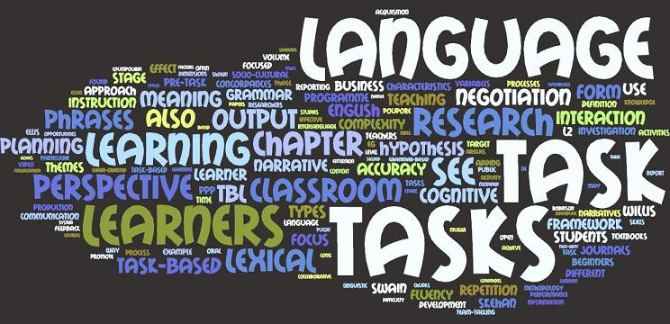

A task-based approach focusing on form does not mean a complete neglect or avoidance of forms. It’s not a matter of existence, but a matter of primacy. In a language class, meaning should always be the primary focus and initial aim of teaching, as to facilitate and ease language learners’ process of communication. Guidance of grammars and structures may be provided at a later stage, but only under the premise that it will not impede the learners’ communication or make them worry too much about accuracy.

Just like designing food packaging that we need to provide consumers both the product information (form) and nutrition facts (forms), but which comes first or in another way, which should be printed in the front? Consumers will only notice the nutrition facts after their attention get caught and know what product they are purchasing. Similarly, learners will only notice the forms after they understand the meaning.