A sequence of tasks in a task-based classroom
A task-based lesson usually involves a sequence of tasks that have different characteristics and purposes but all focus on meaning and inextricably relate to each other.
When teachers plan a sequence of tasks, they should keep the target tasks in mind as the starting point and build facilitating tasks that prime and prepare the learners for the target tasks. During these stages, learners have heard new vocabularies and grammars related to the task several times and may some concern about certain language forms. Therefore, form (grammar)-focused activities at the end of the sequence of tasks do not detract from the focus on meaning; on the contrary they will help learners make sense of the target language.
A sequence of tasks in a task-based classroom may look like this:
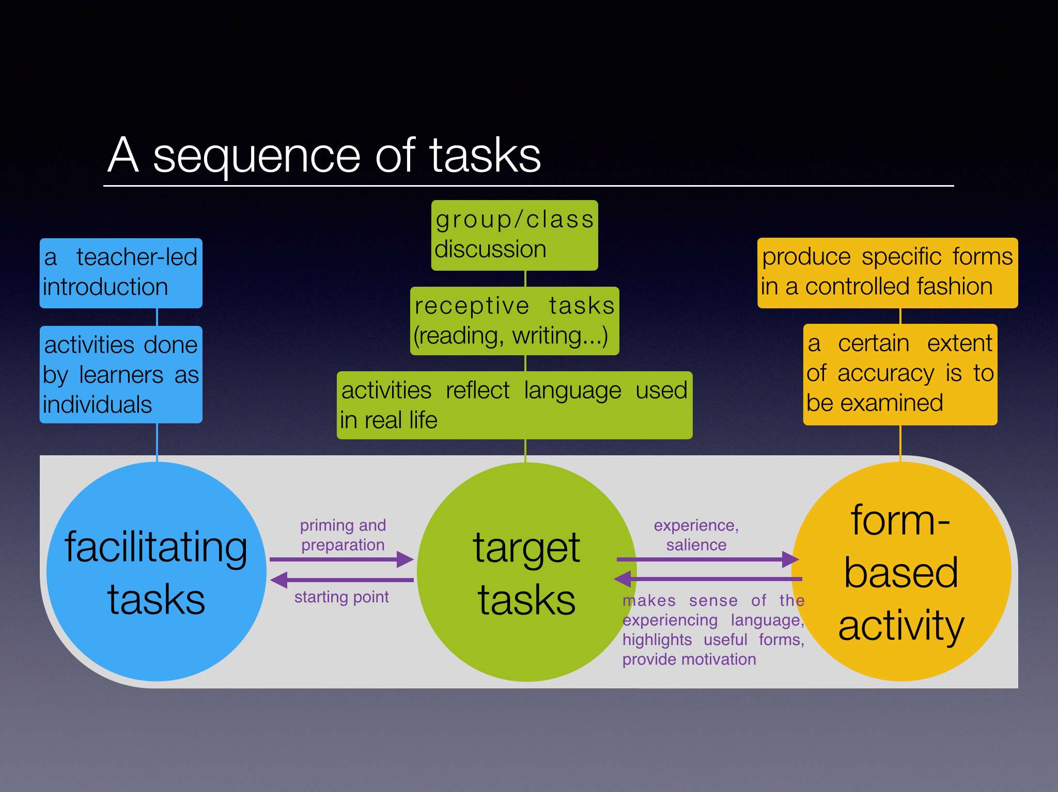Also, this sequence does not need to be covered in one single lesson. Teachers can divide this sequence into several lessons or take out one stage of tasks as homework.

